# Amazon Virtual Private Cloud - VPC - Building Public and Private Subnets

## Tasks

### Create a VPC

**IPv4 CIDR** 10.0.0.0/16

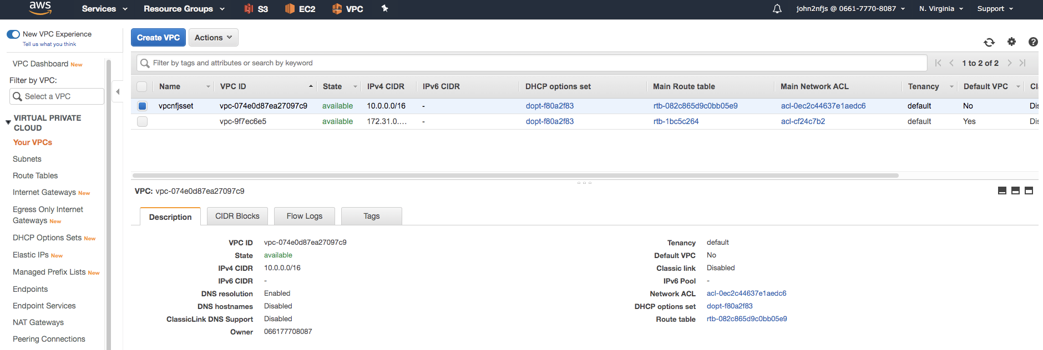

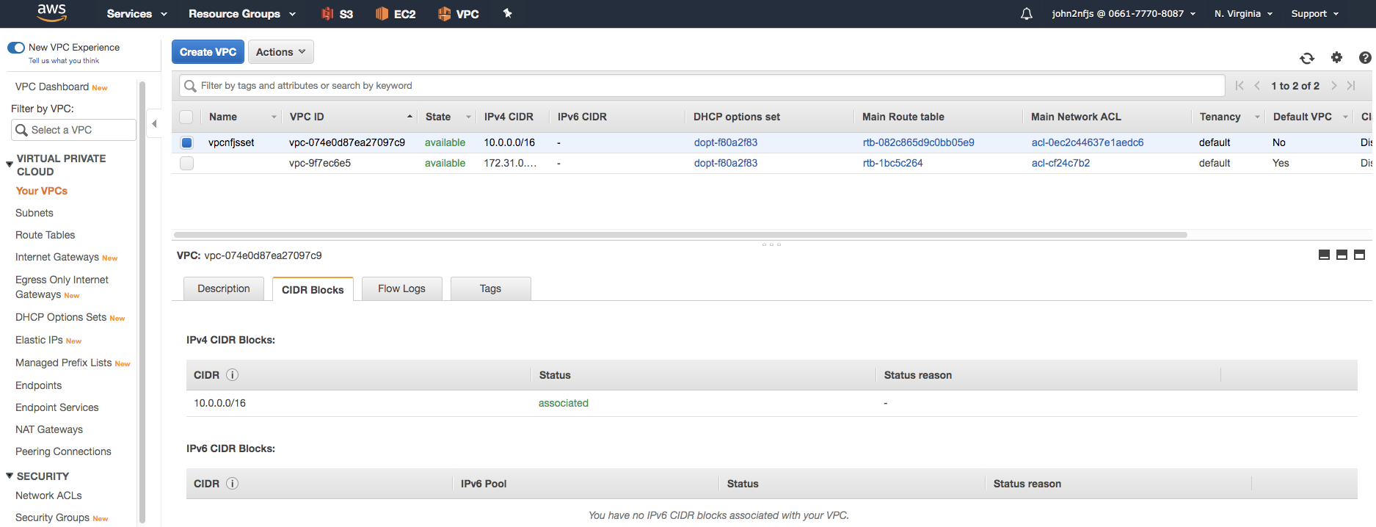

### Add VPC Tag: vpcnfjsset

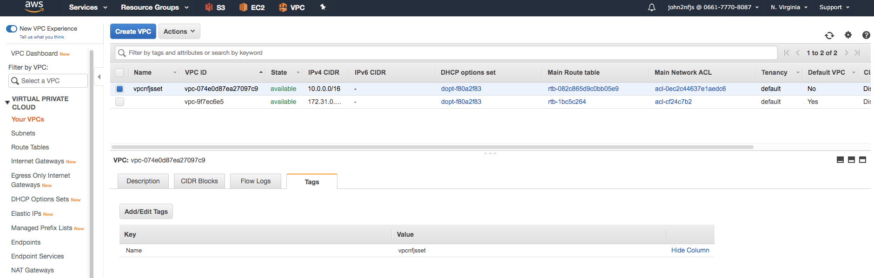

Create an Internet Gateway

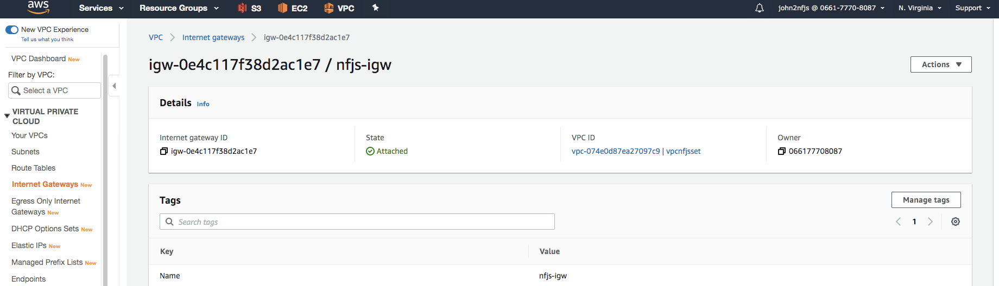

### Create private and public subnets for the VPC

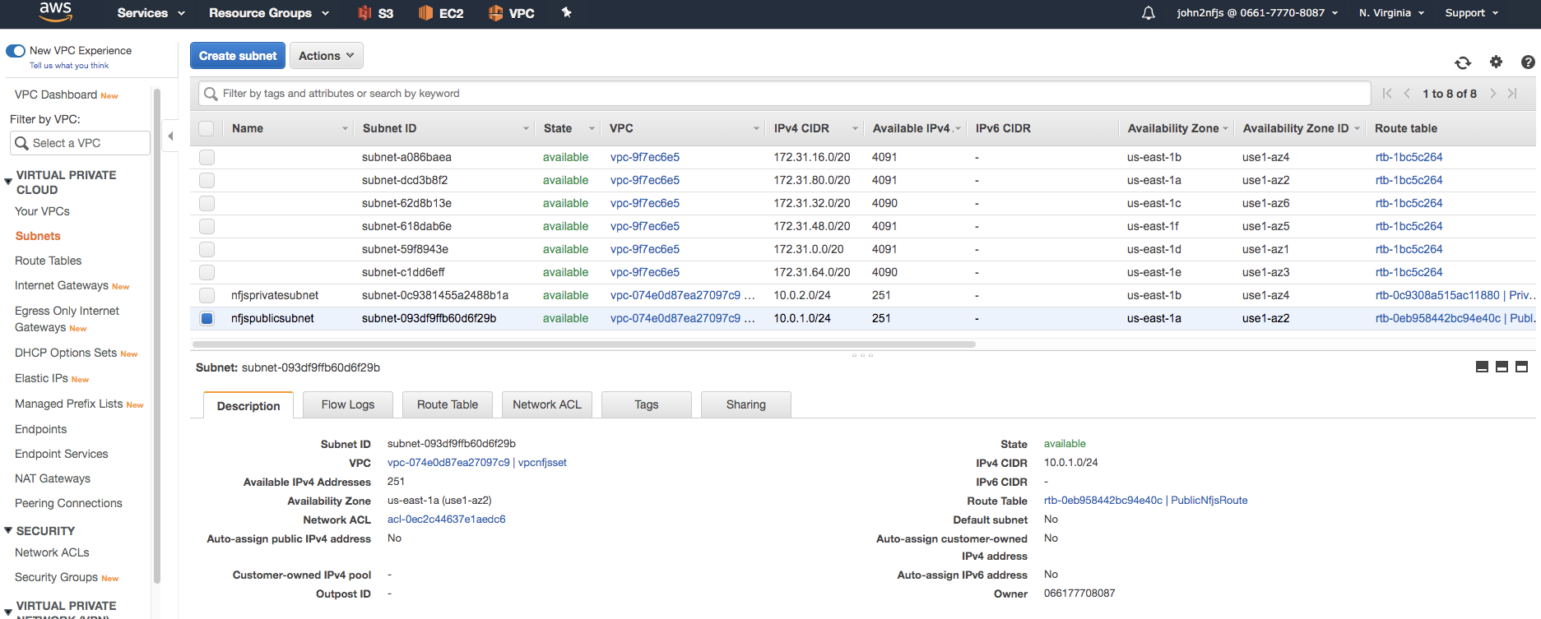

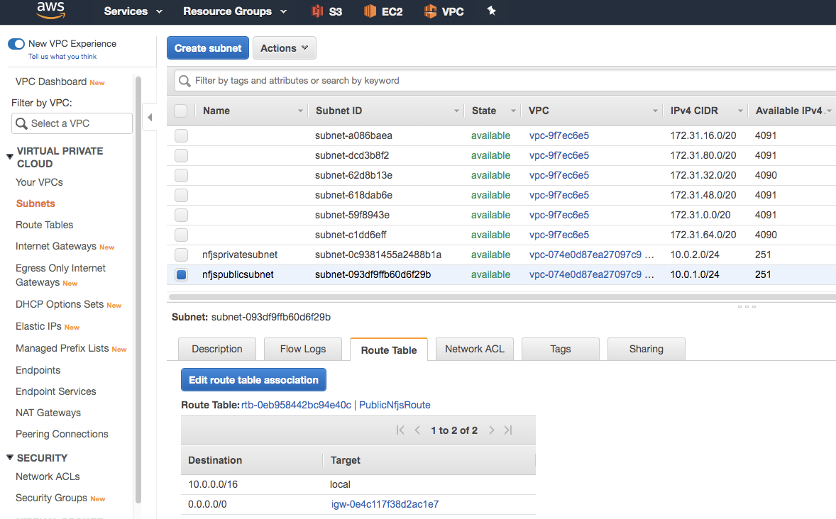

|  |  |  |
| --- | --- | --- |
| **Destination** | **Target** |  |

|  |  |  |
| --- | --- | --- |
| 10.0.0.0/16 | local |  |
| 0.0.0.0/0 | [igw-0e4c117f38d2ac1e7](https://console.aws.amazon.com/vpc/home?region=us-east-1#igws:filter=igw-0e4c117f38d2ac1e7) |  |

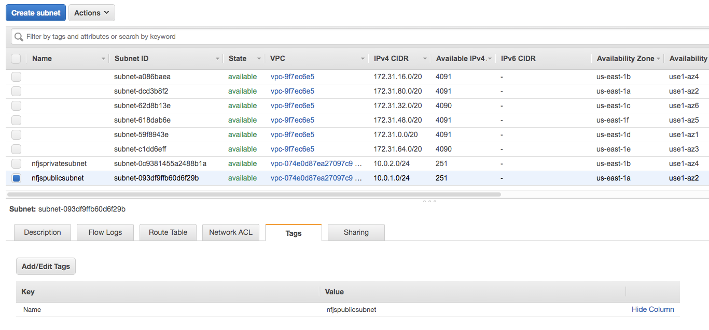

Private

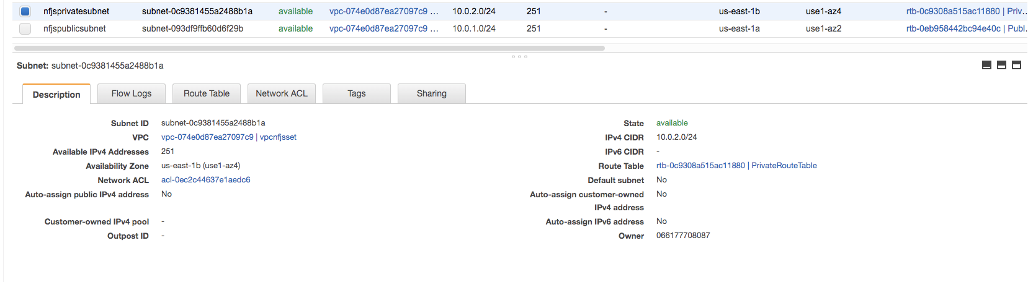

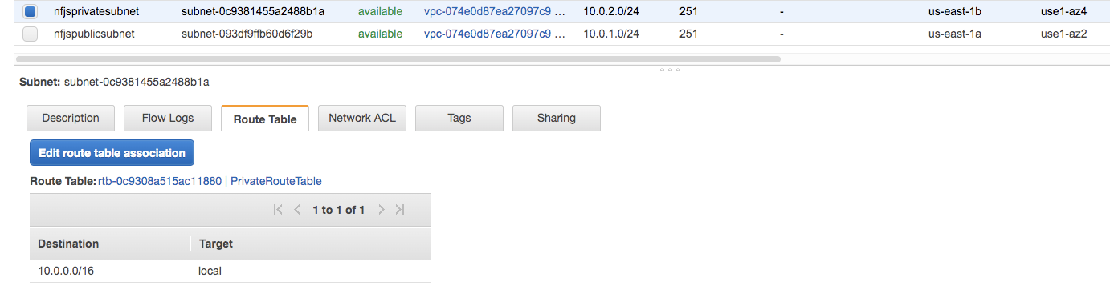

|  |  |  |
| --- | --- | --- |
| **Destination** | **Target** |  |

|  |  |
| --- | --- |
| 10.0.0.0/16 | local |

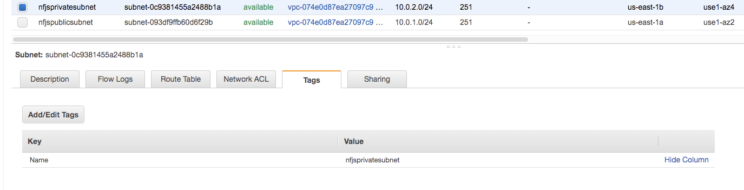

### Create and Configure Route tables

